Graph Cut Segmentation

* Graph Cut Segmentation is an advanced image segmentation technique that uses principles from graph theory to divide an image into distinct, meaningful regions such as foreground and background.
* The image is represented as a graph, where each pixel (or group of pixels) becomes a node, and connections (edges) between pixels represent similarity or neighborhood relationships.
* By modeling the segmentation task as a graph partitioning problem, the algorithm aims to find the optimal boundary that separates different regions of interest. This is done using a powerful technique known as the minimum cut / maximum flow algorithm, which determines the best way to “cut” the graph to isolate objects from the background.

**WORKING**

Graph Cut Segmentation transforms an image segmentation task into a graph optimization problem. The key idea is to model the image as a flow network and find the optimal separation (or “cut”) that best divides the foreground and background based on intensity, texture, or user input.

**1. Graph Construction**

The first step is to convert the image into a graph structure:

* **Nodes (Vertices)**: Each pixel in the image becomes a node in the graph.
* **Edges**: There are two types:
  + **N-links (neighborhood links)**: Connect each pixel to its neighbors (typically 4 or 8-connectivity). These edges reflect the **similarity** between pixels — the more similar, the higher the edge weight.
  + **T-links (terminal links)**: Connect each pixel to two special terminal nodes — the **Source (S)** (representing foreground) and the **Sink (T)** (representing background)

**2. Edge Weights**

Edge weights play a critical role in determining how the cut will be made:

* N-link weights are typically based on a similarity function like:

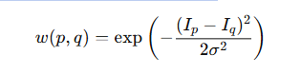

* where Ip​ and Iq​ are intensities of neighboring pixels

σ controls sensitivity.

This encourages the algorithm to avoid cutting between similar pixels.

* **T-link weights** are based on how likely a pixel belongs to foreground or background. This can be determined through:
  + **User input** (like scribbles or bounding boxes)
  + **Probability models** (e.g., Gaussian Mixture Models for color histograms) - The higher the likelihood, the stronger the connection to that terminal node.

**3. Source and Sink Nodes**

Two terminal nodes are introduced:

* **Source (S)**: Connected to pixels likely to belong to the foreground.
* **Sink (T)**: Connected to pixels likely to belong to the background.

The goal is to decide for each pixel whether it should be connected to the source or sink , whether it’s part of the foreground or background.

**4. Min-Cut / Max-Flow Computation**

Now, the algorithm applies a **min-cut / max-flow** algorithm to find the optimal cut:

* A **cut** is a partition of the graph into two disjoint sets: one connected to the source, and the other to the sink.
* The **minimum cut** is the one with the smallest total edge weight between these two sets.
* This cut essentially “removes” the weakest connections (edges with low similarity) between pixels — ideally those between foreground and background.

**5. Final Segmentation**

Once the cut is made:

* All pixels connected to the **source** node are labeled as **foreground**.
* All pixels connected to the **sink** node are labeled as **background**.

The result is a binary segmentation of the image based on the optimal boundary determined by the cut.

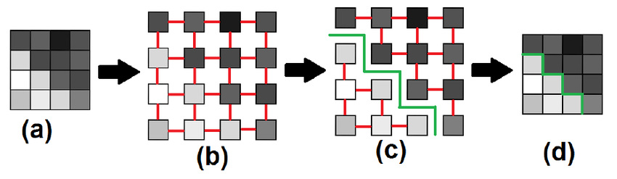

**Advantages**:

**1. Interactive Image Editing**

Works great when users provide rough foreground/background hints. It refines the boundary accurately.

**2. Medical Imaging**

Effective for segmenting organs or tissues, especially with clear contrast and expert guidance.

**3. Smooth Foreground-Background Separation**

Performs well when object and background have distinct colors or textures.

**4. Clean, Low-Noise Images**

Accurate results in images without much noise or complex patterns.

**Disadvantages**

**1. Cluttered or Textured Backgrounds**

Fails when background looks too similar to the object.

**2. Noisy or Low-Contrast Images**

Struggles to find boundaries if the image lacks clear edges or is grainy.

**3. Large Images or Real-Time Needs**

Can be slow and memory-heavy for high-res or real-time applications.

**4. Ambiguous or Weak User Input**

Needs clear foreground/background hints — poor input leads to poor segmentation.